From January 2022, Paavo Järvi will be conducting a Bruckner cycle with the Tonhalle Orchestra Zurich that will span several seasons. A look at the history of our dramaturg Ulrike Thiele shows how well this composer suits us.
From the very beginning, the Zurich Tonhalle Orchestra felt obliged to perform “novelties”, i.e. contemporary music. At the time the New Tonhalle opened in 1895, these were works by Johannes Brahms and Richard Strauss. The driving force was initially Friedrich Hegar, the first chief conductor of the Tonhalle Orchestra, who maintained excellent contacts with the leading musicians and composers of the time. In January 1898, Strauss himself came to Zurich to conduct, among other things, “Also spoke Zarathustra” – as Hegar “prepared the work, had the strings stand by the podium […] that was on everyone’s lips at the time.” (E. Isler, New Year's Journal 1935) A special programmatic constant goes back to Strauss, who performed Bruckner for the first time in 1903 as a guest performance with the Berlin Philharmonic Orchestra,
Volkmar Andreae, who took over the post of chief conductor from Hegar in 1906, had further Zurich premieres follow: 1907 Symphony No. 9 and 1909 Symphony No. 4). In the early decades, the fourth and third played particularly often, followed by the eighth and seventh. With his numerous Bruckner performances, Andreae established the Bruckner tradition, which extends to the present day and is now being continued with the Bruckner cycle by Paavo Järvi and the Tonhalle Orchestra Zurich.
For our Music Director, Bruckner is a particularly good match for the orchestra:
«With its great classical-romantic tradition, the Zurich Tonhalle Orchestra is ideally suited for Bruckner, this central composer for modern symphonic orchestras. If Bruckner's music has repeatedly been dismissed as 'static' in the past, one does it an injustice. Because that is primarily a problem of interpretation. His music has the same merits, values ​​and aspects of the symphonies of Brahms, Mendelssohn, Schumann, Beethoven. Bruckner is the natural continuation of this tradition. Even though the Zurich Tonhalle Orchestra has often played Bruckner and I also conduct it, I'm looking forward to discovering a lot of new things together. And with the Symphonies Nos. 4 and 7, there are two works at the beginning of this cycle that are rightly very popular: because they speak to us very directly.»
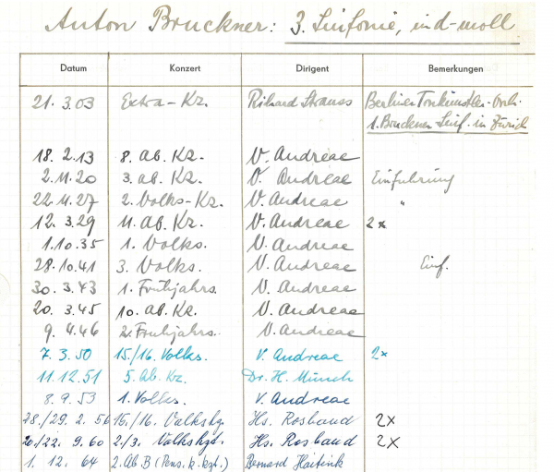
A look into the archives of the Tonhalle Society in Zurich: the first Bruckner performance in Zurich in 1903

Bruckner's works in Zurich and Switzerland
1880 Bruckner travels through Switzerland and presumably plays his own works on various organs
November 21, 1896 The first documented performance of a work by Bruckner in Switzerland takes place in Lucerne: three movements from his Symphony No. 7
March 21, 1903 A (complete) symphony by Bruckner is performed for the first time in Switzerland: Symphony No. 3 at a guest performance by the Berlin Tonkünstler Orchestra in the Zurich Tonhalle, conducted by Richard Strauss
29 November 1903 Hermann Suter, one of the most important early patrons of Bruckner's works in Switzerland, performs Symphony No. 8 in Basel
March 7, 1904 Symphony No. 4 is performed for the first time in Switzerland: in Geneva under Willy Rehberg
20./21. January 1919 First performance of Symphony No. 4 in Zurich, with the Tonhalle Orchestra under Volkmar Andreae
1927/28 Volkmar Andreae cyclically performs all Bruckner symphonies in one season and makes Zurich a center of Bruckner cultivation
1942 to 1948 In the 1940s too, Andreae Bruckner's symphonies were on the program in close succession, documented by recordings by Radio Beromünster.
1953 First complete recording of Bruckner's symphonies by Volkmar Andreae with the Vienna Symphony Orchestra
Since the 1950s , i.e. following Volkmar Andreae as chief conductor, well-known chief conductors and guest conductors have devoted themselves to the works of Bruckner and brought their interpretations to the Tonhalle Orchestra Zurich:
Hans Rosbaud (1952 No. 2, 1954/58 No. 6, 1955 No. 4, 1956/60 No. 3, 1957 No. 9, 1962 No. 1), Bruno Walter (1954 No. 9), Otto Klemperer ( 1956 No. 7), Erich Schmid (1960 No. 1, 1969/87 No. 6), Joseph Keilberth (1960 No. 7, 1964 No. 6, 1966 No. 8, 1968 No. 4), Bernard Haitink (1964 No. 3, 2003 No. 6, 2007 No. 8, 2009 No. 5, 2017 No. 4, 2018 No. 7), Rudolf Kempe (1966 No. 4 and 7, 1967/72 No. 5, 1968/71 No. 8, 1970 No. 9), Wolfgang Sawallisch (1966 No. 6, 1973 No. 3), Vaclav Neumann (1971 No. 4), Karl Böhm (1971 No. 7, 1974 No. 8), Ferdinand Leitner ( 1973 No. 9, 1974 No. 4, 1976/81 No. 6), Günter Wand (1975 No. 5), Christoph von Dohnányi (1976 No. 3, 2013 No. 4), Gerd Albrecht (1978 No. 4, 1977 No. 8, 1977/78 No. 7 including tour), Christoph Eschenbach (1982/86 No. 7, 1983 No. 4, 1984 No. 8, 1990 No. 6), Lorin Maazel (1987 No. 3) ,Giuseppe Sinopoli (1987 #7), Kurt Masur (1990 #3), Kurt Sanderling (1990 #4, 1997 #3, 2001 #7), David Zinman (1996 #7 and 8, 1998/2016 No. 5), Herbert Blomstedt (1996 No. 9, 2009 No. 2, 1999/2019 No. 4, 2012 No. 8), Marek Janowski (2001, No. 1), Mariss Jansons (2003 No. 3), Andris Nelsons (2011 #4), Kent Nagano (2015 #6), Michael Sanderling (2016 #4), Franz Welser-Möst (2017 #8), Juanjo Mena (2019 #6)
June/July 2005 The last major Bruckner cycle with the Zurich Tonhalle Orchestra took place as part of the Zurich Festival: the «Zero», Symphony No. 1, No. 2 and No. 6 conducted by Stanislaw Skrowaczewski, No. 3 with Riccardo Chailly, No. 4 with Philippe Herreweghe, No. 5 and No. 8 with Herbert Blomstedt, No. 7 and No. 9 with Bernard Haitink
- © Tonhalle-Gesellschaft Zürich AG
Unsere Website wird klimaneutral betrieben.

